Role-Based Access Database Credential
# Source: AI Source: Provided by: [Data Path: Persons Table -> ID Column: 1, Name_En Column: Motasem Essam] -> From: [ChatGPT] on [1/18/2026]
A Role-Based Access Database Credential is a method of controlling database access and permissions based on roles assigned to users or applications rather than giving each user individual privileges. It is commonly used to enforce the principle of least privilege.

👤 What It Is
# Source: AI Source: Provided by: [Data Path: Persons Table -> ID Column: 1, Name_En Column: Motasem Essam] -> From: [ChatGPT] on [1/18/2026]
- Role: A collection of permissions in the database (e.g., read, write, admin).
- User account: Assigned one or more roles instead of individual permissions.
- Purpose: Simplifies access management and reduces risk of over-privileged users.
Example (PostgreSQL)
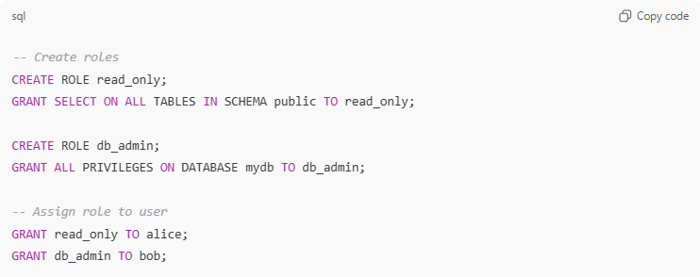
-- Create roles
CREATE ROLE read_only;
GRANT SELECT ON ALL TABLES IN SCHEMA public TO read_only;

CREATE ROLE db_admin;
GRANT ALL PRIVILEGES ON DATABASE mydb TO db_admin;

-- Assign role to user
GRANT read_only TO alice;
GRANT db_admin TO bob;
- Alice can only read tables.
- Bob can perform all administrative actions.

🛠️ How It Works
# Source: AI Source: Provided by: [Data Path: Persons Table -> ID Column: 1, Name_En Column: Motasem Essam] -> From: [ChatGPT] on [1/18/2026]
- Database administrator creates roles with specific permissions.
- Users are assigned one or more roles based on their job function.
- When a user connects, the database enforces permissions defined by the role(s).
- If a user tries an action outside their role → access denied.
Roles can also be nested or combined for more flexible permissions.

📍 Where It’s Used
# Source: AI Source: Provided by: [Data Path: Persons Table -> ID Column: 1, Name_En Column: Motasem Essam] -> From: [ChatGPT] on [1/18/2026]
- Enterprise databases (MySQL, PostgreSQL, Oracle, SQL Server)
- Multi-user applications with different access levels
- SaaS products with administrative and read-only roles
- Any environment where access control needs to scale

✅ Advantages
# Source: AI Source: Provided by: [Data Path: Persons Table -> ID Column: 1, Name_En Column: Motasem Essam] -> From: [ChatGPT] on [1/18/2026]
- Centralized permission management → easier to maintain
- Supports least privilege principle
- Roles can be reused across multiple users
- Easier to audit and track permissions

⚠️ Disadvantages
# Source: AI Source: Provided by: [Data Path: Persons Table -> ID Column: 1, Name_En Column: Motasem Essam] -> From: [ChatGPT] on [1/18/2026]
- Misconfigured roles can give users too much or too little access
- Requires proper role design and planning
- More complex than single username/password permissions

🔒 Best Practices
# Source: AI Source: Provided by: [Data Path: Persons Table -> ID Column: 1, Name_En Column: Motasem Essam] -> From: [ChatGPT] on [1/18/2026]
- Define roles based on job function or application needs
- Grant minimum necessary permissions
- Audit and review roles regularly
- Avoid giving multiple users administrative roles unnecessarily
- Combine with strong authentication (password, certificate, IAM, etc.)

🧠 Authentication Factor
# Source: AI Source: Provided by: [Data Path: Persons Table -> ID Column: 1, Name_En Column: Motasem Essam] -> From: [ChatGPT] on [1/18/2026]
- Something you know → password or token for the user
- Authorization is enforced via roles

Role-Based Access Database Credential vs IAM-based credentials
# Source: AI Source: Provided by: [Data Path: Persons Table -> ID Column: 1, Name_En Column: Motasem Essam] -> From: [ChatGPT] on [1/18/2026]
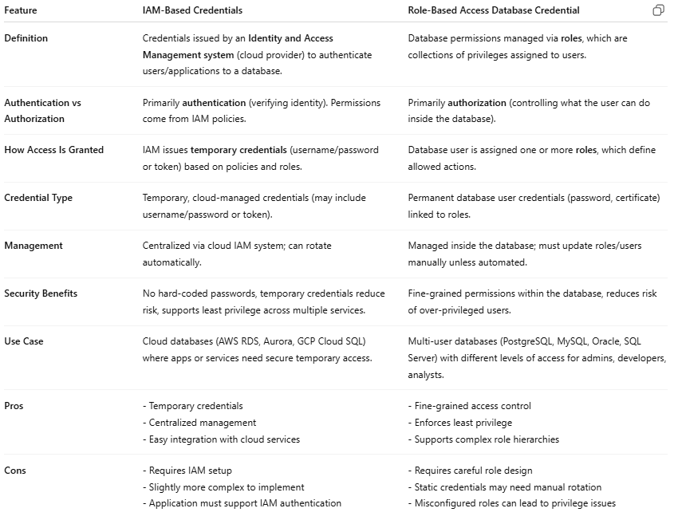
Feature | IAM-Based Credentials | Role-Based Access Database Credential
Definition | Credentials issued by an Identity and Access Management system (cloud provider) to authenticate users/applications to a database. | Database permissions managed via roles, which are collections of privileges assigned to users.
Authentication vs Authorization | Primarily authentication (verifying identity). Permissions come from IAM policies. | Primarily authorization (controlling what the user can do inside the database).
How Access Is Granted | IAM issues temporary credentials (username/password or token) based on policies and roles. | Database user is assigned one or more roles, which define allowed actions.
Credential Type | Temporary, cloud-managed credentials (may include username/password or token). | Permanent database user credentials (password, certificate) linked to roles.
Management | Centralized via cloud IAM system; can rotate automatically. | Managed inside the database; must update roles/users manually unless automated.
Security Benefits | No hard-coded passwords, temporary credentials reduce risk, supports least privilege across multiple services. | Fine-grained permissions within the database, reduces risk of over-privileged users.
Use Case | Cloud databases (AWS RDS, Aurora, GCP Cloud SQL) where apps or services need secure temporary access. | Multi-user databases (PostgreSQL, MySQL, Oracle, SQL Server) with different levels of access for admins, developers, analysts.
Pros | - Temporary credentials- Centralized management- Easy integration with cloud services | - Fine-grained access control- Enforces least privilege- Supports complex role hierarchies
Cons | - Requires IAM setup- Slightly more complex to implement- Application must support IAM authentication | - Requires careful role design- Static credentials may need manual rotation- Misconfigured roles can lead to privilege issues

